March 18, 2022

The Honorable Gary Gensler
Chair
U.S. Securities and Exchange Commission
100 F Street NE
Washington, D.C. 20549

Dear Chair Gensler:

We write to express our great concern regarding the Commission’s upcoming rulemaking calendar. In light of recent geopolitical events, we are unquestionably at a time when we need a whole-of-government approach to increasing and encouraging domestic energy production of all sources. In a remarkably tone-deaf act, however, the Commission has scheduled an open meeting to propose that all public companies make climate-related disclosures, regardless of whether climate-related risks are material to a company’s business.

Beyond concerns that these rulemakings will likely hinder the supply of domestic energy and ultimately raise energy costs for the American people, we should note that this is precisely the type of “mission creep” Financial Services Committee Republicans warned you about in a letter the first day you took office. We are disappointed that you have failed to heed our advice.

Let us be clear about what is going on. The SEC is engaging in these rulemakings to advance the Biden Administration’s environmental agenda. The intellectual foundation for these rulemakings leaves little doubt that the purpose of these rulemakings is not truly an attempt to provide financially material information to investors for all companies; the real intent is to fight climate change. Congress, however, has not passed any securities-related law that would allow for that to be a legitimate aim of Commission rulemaking. If and until that happens, the Commission must act consistently within its historical bounds, or rulemakings like these should and likely will be thrown out in federal court.

Instead of wasting taxpayer dollars on rulemakings designed to raise American energy prices in a manner that would harm U.S. foreign policy, the Commission should indefinitely freeze its work on this and other climate-related rulemakings. We call on you to cancel next week’s open meeting and remove these rulemakings from the Commission’s agenda.

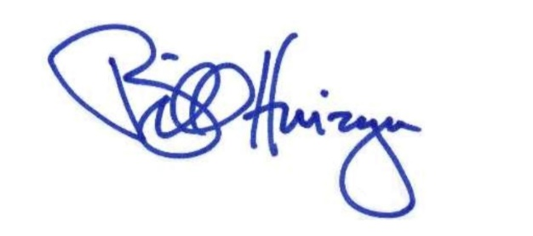
Sincerely,
______________________
Bill Huizenga
Ranking Member
Subcommittee on Investor Protection, Entrepreneurship, and Capital Markets

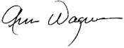
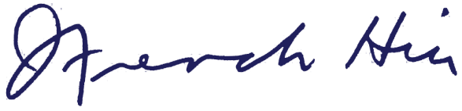

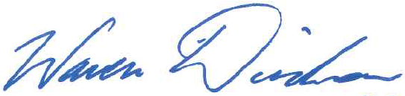
______________________ ______________________
Ann Wagner French Hill
Member of Congress Member of Congress
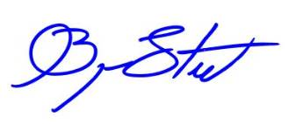
______________________ ______________________
Tom Emmer Warren Davidson
Member of Congress Member of Congress
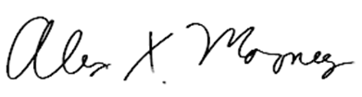
______________________ ______________________
Alex Mooney Bryan Steil
Member of Congress Member of Congress

cc: The Honorable Hester M. Peirce, Commissioner
The Honorable Allison Herren Lee, Commissioner
The Honorable Caroline A. Crenshaw, Commissioner

See Securities and Exchange Commission, Open Meeting Agenda – March 21, 2022, available at https://www.sec.gov/os/agenda-open-032122.
See Letter from the Hon. Patrick McHenry and the Hon. Bill Huizenga to the Hon. Gary Gensler dated April 19, 2021, available at https://republicans-financialservices.house.gov/uploadedfiles/2021-04-19_gensler_priorities_letter.pdf.
See President Joseph R. Biden, Executive Order on Tackling the Climate Crisis at Home and Abroad (Jan. 27, 2021).
See, e.g., Commissioner Allison Herren Lee, Remarks at the PLI/LSEG Investor Action of Climate Webinar (Oct. 20, 2021) (“[L]et me not mince words: climate change presents an existential threat to life on the planet. While it’s important to consider the issue, as the SEC does, through the lens of the risks and opportunities in financial markets, there is a level at which that grossly underestimates what is at stake.”); Commissioner Caroline A. Crenshaw, Virtual Remarks at the Center for American Progress and Sierra Club: Down the Rabbit Hole of Climate Pledges (Dec. 14, 2021) (“Climate change is a crisis that poses an existential threat to our society, and our capital markets will not escape the impact.”); Tyler Gellasch and Lee Reiners, From Laggard to Leader: Updating the Securities Regulatory Framework to Better Meet the Needs of Investors and Society (Feb. 2021) (“Climate change, systemic racism, and unprecedented income and wealth inequality pose direct and immediate threats to our capital markets… Now more than ever, it is crucial that investors, stakeholders, and the public have the power to hold corporations accountable….”).
For discussion of the importance of investment-related materiality in Commission rulemaking and how that is tethered to the appropriate interpretation of the federal securities laws, see Commissioner Elad L. Roisman, Can the SEC Make ESG Rules That Are Sustainable? (Jun. 22, 2021).

